Enthusing More Children to Cycle
Free
Bikeability Level 1 & 2 Cycle Training Parental Information
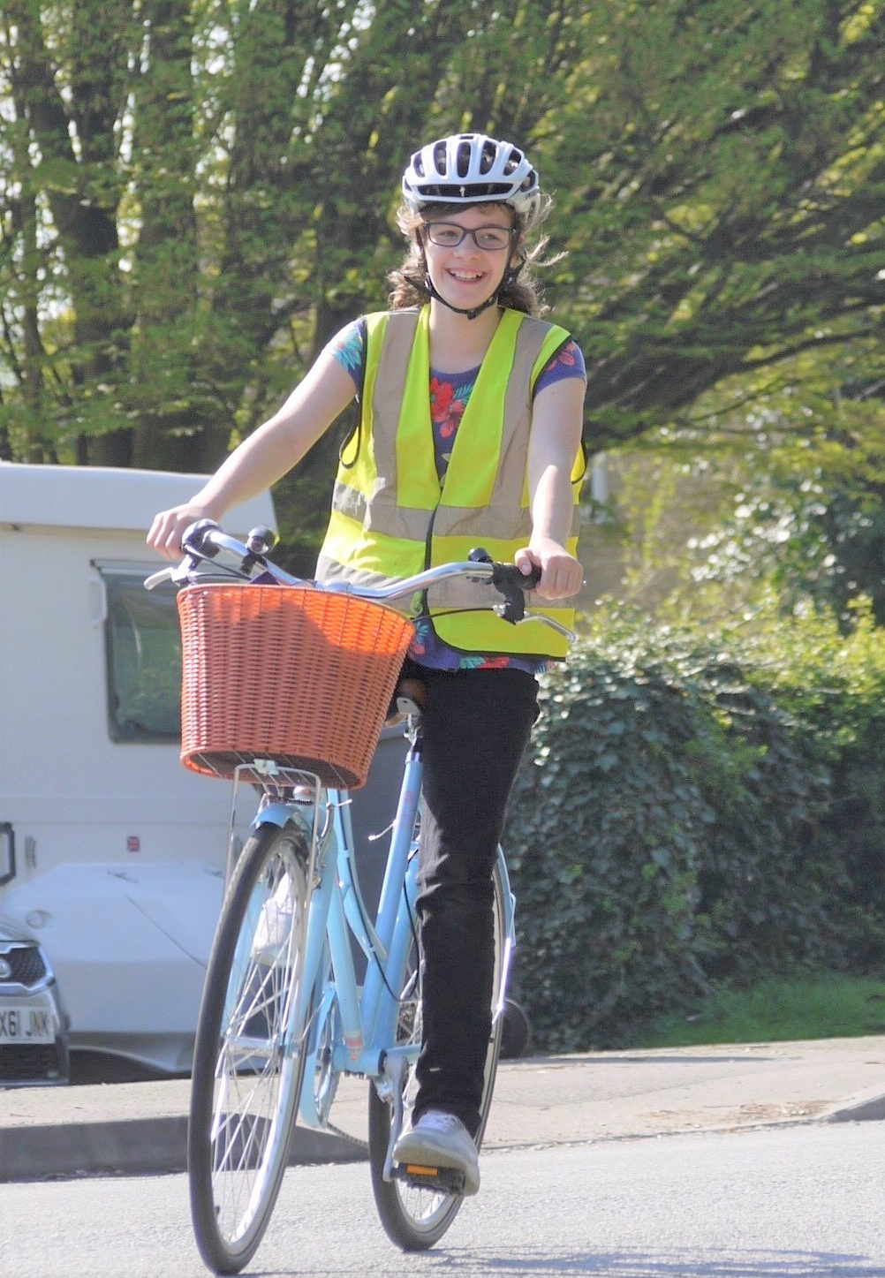
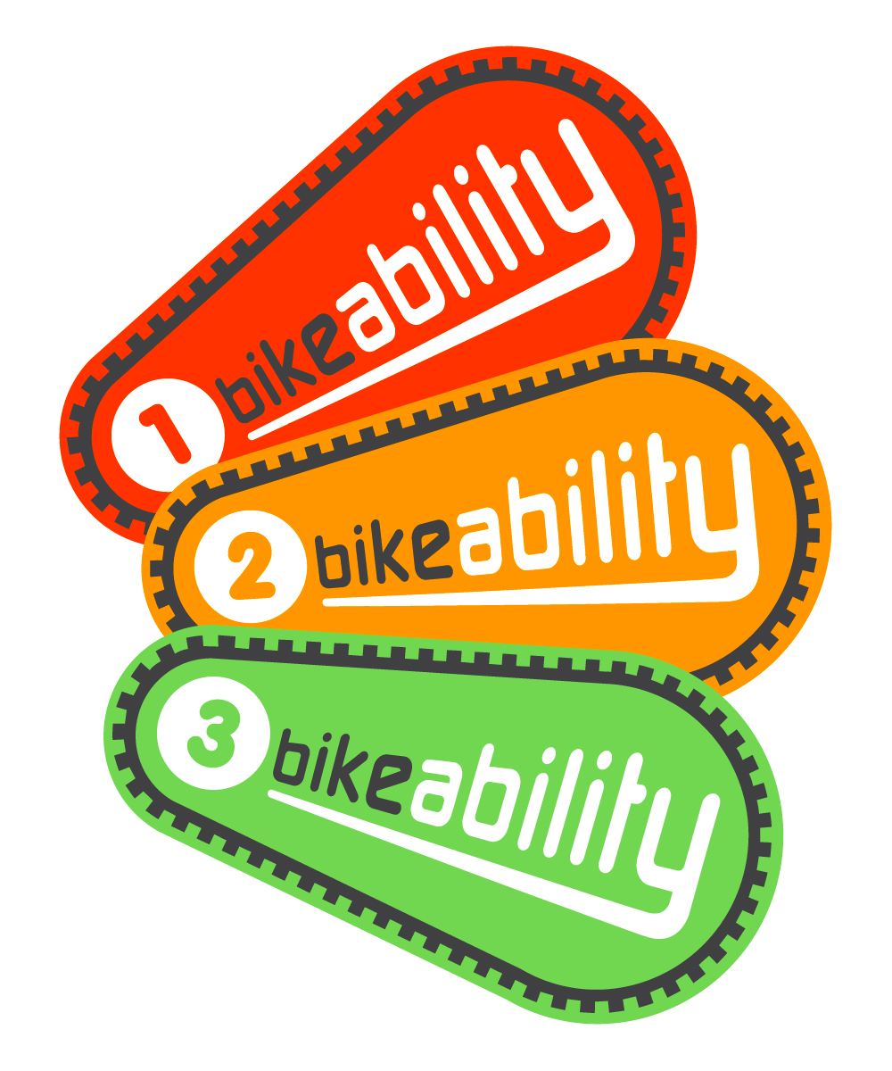




Bikeability is the government’s national cycle training programme. The scheme aims to inspire more children to cycle by equipping them with the skills and confidence to ride more.
Bikeability

All the training is delivered by Outspoken Training’s qualified and DBS checked Instructors.
Bikeability Level 1 & 2 Course

This course is suitable for riders who have mastered control of their cycle and are ready to learn how to ride independently on local roads.

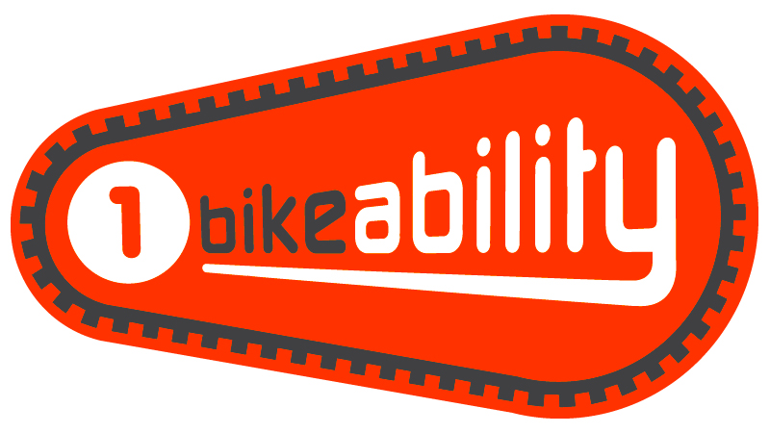
Level 1: Through fun, progressive games, pupils must demonstrate the following to progress onto on-road training:

- Pedal independently without stabilisers (this is not a learn to ride course)
- Apply brakes to bring the cycle to a smooth and quick stop
- Look behind over each shoulder while pedaling in a straight line
- Pedal one handed in a straight line (signal)
- Use gears (if present)
- Avoid hazards
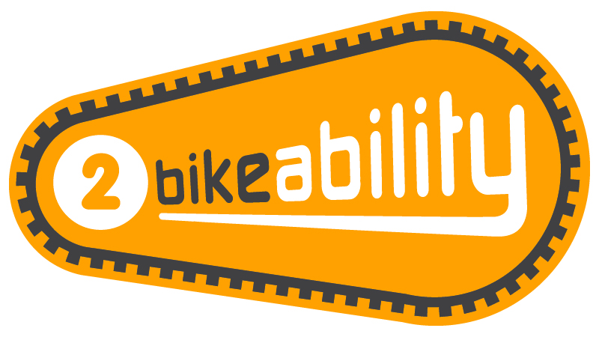
Level 2: Riders will be taken onto residential roads to experience ‘real’ road cycling covering:

- Starting and stopping journeys
- Passing stationary vehicles
- Understanding road signals, signs and markings
- Negotiate junctions
- Sharing the road with others

For more information on Bikeability, please visit www.bikeability.org.uk
Dates: 27th – 30th January 2025
Year Group: Year 6
Number of Sessions: 4
Format: Session 1: Level 1 & Sessions 2-4: Level 2
Times: Throughout the school day
Cost: FREE! - Funded by Cambridgeshire County Council
Course Information
What Will Your Child Need?

- A consent form (see overleaf)
- A roadworthy cycle without stabilisers (see overleaf) – we are unable to provide cycles.
- A helmet
- Suitable clothing for cycling and the weather conditions
Further Information for Parents/Guardians

- The course is not suitable for non-riders.
- Riders must demonstrate all Level 1 activities (see left) during the first session to progress to Level 2 for the remainder of the course. We highly recommend practicing these skills with your child before the course.
- Please encourage your child to practice in between each session and where possible, cycle to and from school with them.
- We also offer one to one training for children and adults via www.outspokentraining.co.uk
- All participants receive a badge and certificate.
How to Book

Bikeability places are limited and will be booked by the school on a first-come basis.

Please complete and return a consent form (see overleaf) to school as soon as possible.

Deadline: Wednesday 23rd October 2024
Cycle & Helmet Checklist – Compulsory Helmets
Please check your child’s cycle before the start of the course. If the bicycle is not roadworthy, pupils won’t be able to participate in the course. Faults are often easily fixed but occasionally a new part from a bike shop is required so please check your child’s cycle well in advance.

Cycle Checklist

Please tick off the cycle checks below:

2. FRAME & SEAT POST:
Is the frame the appropriate size for your child?

Can your child comfortably touch the floor with their toes whilst sat on the saddle?

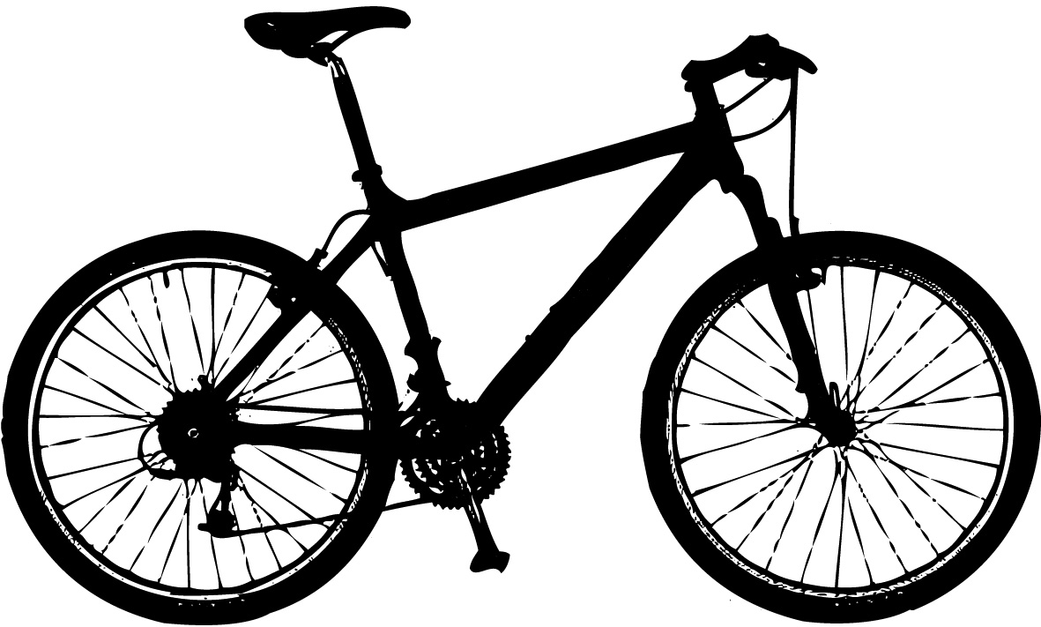

6. GEARS:
If present, do the gears change smoothly without any delays?

5. CHAIN:
Have you cleaned and oiled the chain?

---------------------------------------------------------------------------------------------------------------------------

Level 1 & 2 Course Consent Form

4. TYRES:
Are both tyres inflated to the required tyre pressure stamped on the side of the tyre?

3. BRAKES:
Does the cycle have a working front and rear brake capable of stopping the cycle?

Can your child comfortably reach and operate the brake levers?
Did you know? Many local bike shops offer free cycle checks for Bikeability participants.

For advice and videos on checking cycles, helmets, and clothing before a course, please visit our website: www.outspokentraining.co.uk/parental-information/

Full Name of Child: _________________________________________

School: ________________________________ School Year: ________

Ethnicity: ______________________________ Gender: ____________

Medical Conditions and/or Additional or Special Educational Needs:
1. MECHANICAL CONDITION:
Are the saddle, handlebars and wheel fixed on tight?

__________________________________________________________

__________________________________________________________

Are you happy for your child to be photographed and/or filmed during Bikeability training? Yes No

These images may be used by the school, Outspoken Training or The Bikeability Trust to promote the Bikeability or the organisation.

By consenting, I confirm my child:

- is medically fit to participate in Bikeability.
- can already cycle independently without stabilisers including being able to control the cycle and keep it moving in a straight line whilst signaling and whilst looking behind. I understand my child won’t be allowed onto local roads if they don’t demonstrate the Bikeability Level 1 assessment criteria during the first, playground-based session.
- will bring a roadworthy cycle for each session (see enclosed information). I understand that cycle training will be refused if the cycle is not roadworthy. If unsure, I will seek the advice of a professional mechanic well before Bikeability training. I understand Instructors may make minor adjustments to the cycle but will not have time to make repairs or replace parts.
- will bring and wear a helmet which conforms to British Standard EN 1078:1997 for each session.
- will have cycling and weather appropriate clothing for each session.
- may be refused cycle training if their behaviour or ability puts them or others at risk. Safety is Outspoken’s main priority.

By consenting for my child to take part in Bikeability, I understand that pupil data will be collected and shared between my child’s school, Outspoken Training and Cambridgeshire County Council. This will be used to support the delivery and monitoring of training courses. More information on how Outspoken Training processes data can be found in their ‘Privacy Policy’ on their website.

I confirm I have read all the information enclosed in the ‘Parental Information’ and consent to my child (or the above child for whom I take responsibility) to take cycling training lessons, which may include cycle maintenance as well as riding on the public highway.

Signed: _____________________________________ parent/guardian

Date: _____________________________________________________

